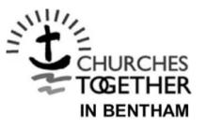
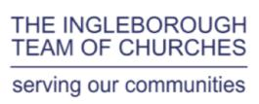
'CARING FOR GOD’S WORLD'

No 5 – June 2020.
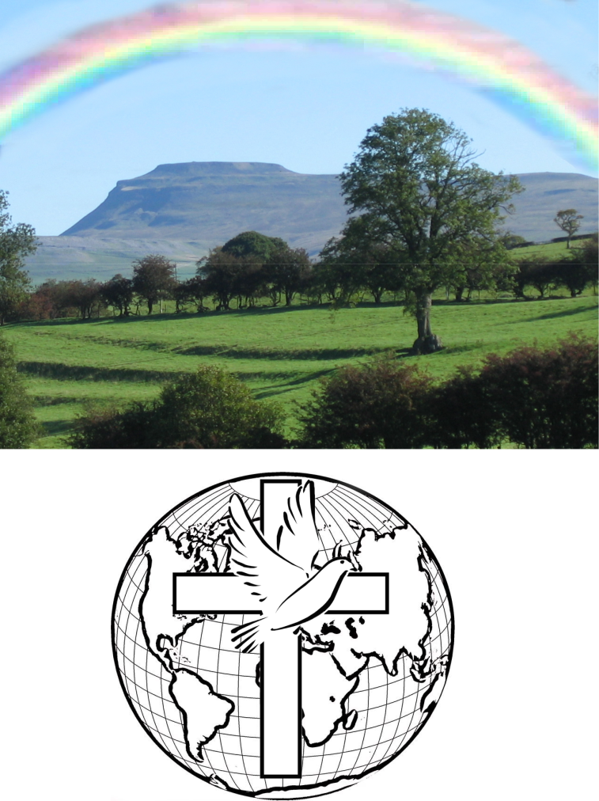

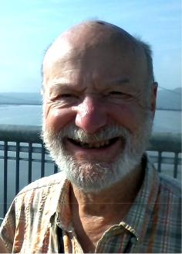
EDITORIAL

In this, the 5th edition of our eco-magazine, we focus on the theme of HOPE - looking ahead to whatever will happen as we emerge from this coronavirus crisis. Thanks to the other two contributors, Andy Ive and Robert Cohen. Thanks to Dave Lewis who has again set it up for publication and printed off a small number of A5 booklets. As before it will be on the website: https:// ingleboroughchurches.org.uk/aboutus/ecomagazine

It will also be available on request from me by email, wenningfoxes@btinternet.com, or printed copy, free of charge. Ring 015242 – 62575, and I can post it to you. We hope to leave some copies in accessible places like the Pop-Up Pantry in Bentham.

You are welcome to send in comments, questions and suggestions for future editions…. More contributors please!

 |  | Timothy Fox
CONTENTS |  | Page no.
The Rainbow | Timothy Fox | 3
Hope for the Future | Timothy Fox | 4
Lessons from Covid19 | Robert Cohen | 5
The C-word again | Andy Ive | 7
Doing things Differently | Timothy Fox | 10
The Long-Eared Owl | Timothy Fox | 12

2

THE RAINBOW, SYMBOL OF HOPE

“Praise be to the God and Father of our Lord Jesus Christ! In his great mercy he has given us new birth into a living hope through the resurrection of Jesus Christ from the dead…” 1 Peter 1:3

Look at the rainbow, in itself a beautiful thing, reflecting the beauty and variety in creation. See the front cover of this eco magazine. Many people have put rainbows in their windows as a sign of hope.
It sometimes appears as if it is linking the sky (the clouds) to the earth, so is this why to Noah it became a symbol of God’s caring for the world? A sign of God with us and for us!

God promises Noah and his family that as long as there is a world (Earth) there would be life, seedtime and harvest, for them and for their descendants. You have to have both sun and rain to produce the rainbow and you have to have both to produce food.

But notice also the rainbow is just a symbol, a symbol of hope but not the grounds for hope. See 1 Peter 1:3 above. The death and resurrection of Jesus brought about radical change, a transformation of people and their expectations of God. Hope for the Christian means expecting God to act or to give or to enable us to act – always for the best, for our good and for the fulfilment of his promises to give us life, life with himself, life in all its abundance and goodness and beauty.

Reasons to be hopeful:

Here are some extracts from an article by Lucy Jolin in the Lent 2020 Cam, the Cambridge Alumni Magazine: “Hope, as Emily Dickinson famously wrote is the thing with feathers …. like the bittern, an elegant, secretive brown heron

known mostly for its eerie, booming mating cry which used to echo across its native wetlands in Suffolk and Lancashire. Over the decades the seas rose and the edgelands moved ever inland. The wetlands vanished and the bitterns did too. By 1997, they were almost extinct in the UK: there were just 11 males

3

left. But now, thanks to the RSPB’s wetlands at Lakenheath Fen [near

Cambridge] …, the bitterns are booming again. Eight to 10 breeding males live on just this one site. [And there are some at Leighton Moss]….
“If there is hope for the bitterns, then surely there is hope for us …”

The writer includes a reference to American presidents including a message of hope in their campaigns. “Obama’s combination of fierce intelligence and audacious hope stirred Americans to give him two terms in the White House…” a boost to the morale and hopes of “kids of colour”. She also quotes the former Archbishop of Canterbury, Dr Rowan Williams, who sees hope as “not regarding any situation as closed down…. So what if things get worse? Do I then give way

to despair? No, because even if things get worse, they can’t close down the possibility of change. So that’s why I think hope can survive a lot of practical disappointment. Because it has. Every generation has a reason for not being hopeful. But if you don’t resist, nothing will happen.”

She concludes thus: “Ten years ago, at Lakenheath, a lone pair of cranes joined the bitterns. There were no projects to attract them or funding to find them: they found their own way. Cranes haven’t bred in the Fens for four centuries. Now, around 40 cranes have made the wetlands their home….”

HOPE FOR THE FUTURE

Is God calling us to new ways of ordering our lives to help care for the Planet – having to follow a different lifestyle, more dependent on each other and on the natural world, with more cooperation in local communities. Can we see signs of hope in the way people have found ways to care for the needy and protect “front-line workers”? We have enjoyed in Bentham and elsewhere the Thursday evening clap for the NHS and others – actually seeing our neighbours! And the media including the Bentham News and others and our church leaders have kept us informed of what is happening. Various community groups and individuals have come together to offer help to whoever wants it.

And some of us have overcome isolation by Zooming and Skype. There is more working from home by video, I-phones etc – broadcasting, business, medical consultations, etc. A recent virtual session of the North Yorkshire Rural Commission (NYRC) heard that “Things will not be the same again but we have seen how it is to work remotely and still be effective … travel less and to see the

4

positive effect on the environment… businesses diversify their manufacturing to support PPE needs and shops to go on line to continue to serve their customers”….

The lockdown, they also said, has “helped us to reconnect with some of the most valuable attributes North Yorkshire offers – high quality locally and sustainably produced food, the sense of space and joy of a natural and green environment and the positive impact on personal wellbeing that delivers.” Some reflections on the future:

How can we take seriously the call both to look after the Planet and care for the poor? It is the deprived and vulnerable who suffer the most from the climate crisis and are the least responsible for the spoiling of the planet, carbon emissions, etc. Notice that there are more COVID19 cases and deaths among the poorer sections of the nation as well as in residential care homes

Pope Paul VI said in 1971 that we need “authentic social and moral progress” as well as economic growth and technological progress; that we need profound changes in “lifestyles , models of production and consumption and the established structures of power which today govern societies”.
See my article, Doing Things Differently and Robert Cohen’s about the lessons Covid-19 teaches us.

The GOOD LESSONS WE ARE LEARNING FROM Covid-19
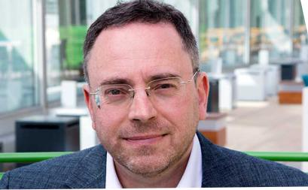

By Robert Cohen

Just when you thought one global crisis was enough to be getting on with, another one comes along bringing with it illness, social disruption and economic turmoil

5

far more immediate than anything climate change has so far created (at least for us in the UK).

Leaving aside the conspiracy theorists, most serious thinking is already joining up the dots to show that Covid-19 is not a separate crisis from global climate change but rather deeply connected to it. The clearing of natural habitats, the growth of industrial farming, the forced displacement of animals and humans, have together created the context in which disease crosses species boundaries with devastating impact.

So it turns out we are not up against a new threat to humanity but instead are faced with a different expression of the same existing crisis we’ve been dealing with (poorly) for some time.

Like the broader challenge of which it’s a part, Covid-19 has revealed itself to be many things: a multiplier of kindness, a generator of anxiety, an accelerator of social and political change, a challenger to accepted wisdom, an exposer of inequality, an exploiter of vulnerability – a truth teller in many ways.

There’s much we’ve been learning in the last few months which could help us with tackling Covid-19’s larger and far more threatening context.

We’ve discovered that we can change how we do things, radically, and at speed, if we understand and accept the urgency of the situation. Our politicians have found that they can let scientific advice shape social and economic policy making – and the voters will accept it. Most significant of all, there’s been a steep learning curve in the value we need to give to individual and community wellbeing. Despite, the £billions being spent by the government, Boris Johnson has already promised that there will be no return to public sector austerity.

Addressing the pandemic meant slamming on the breaks to the world economy. The skies maybe bluer, the birds chirpier, and greenhouse gas emissions significantly down across the globe – but it’s not the way to approach long term climate threats. Not least because it’s the most vulnerable that get hit the hardest by economic shocks. We need a different kind of economy, not no economy.

So, as we recover from the immediate trauma and work our way through a deep recession, we should take the opportunity to think and behave differently.

6

That goes for us as individuals, families and communities, as well as a nation. Lockdown has been tough in many ways. But it’s also created the mental space that allows us to reset our priorities. In particular, why and how we travel, what we spend our money on, and what experiences we most value. At a local level, we must look to maintain the incredible kindness and solidarity that’s been encouraged and nurtured all around us. At a national level, there’s an urgency to ‘build back better’ through a state led project of green infrastructure creation which in turn generates long term ‘green’ employment. If politicians aren’t talking to this agenda you need to ask them why? One of the biggest differences you can make to tackling climate change is through using your vote. Whether it’s your local town councilor or your MP, if they’re not serious about this, don’t vote for them.

Pandemics, like extreme weather events, may no longer be once in a century happenings. As we adapt, and build our collective resilience to these new facts of life, we will have to learn to live differently. That will mean doing and having less – but treasuring what matters more. It’s a physical and a spiritual challenge – and Covid-19 is helping us to understand that.

THE C WORD AGAIN, AND A POSSIBLE SOLUTION
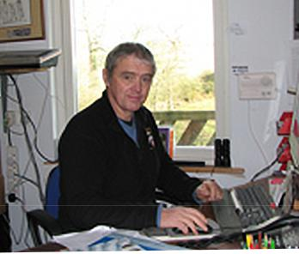

Andy Ive

It is becoming clearer every day that the scale of the societal disruption caused by the novel coronavirus is like nothing most people on Earth have ever witnessed. One stark indicator of the pandemic’s far-reaching impact is its effect on fossil fuel consumption and carbon dioxide emissions. If preliminary

7

data from some of the world’s biggest economies is any indicator, emissions are in for a sharp, if temporary, decline.

In China, carbon emissions were down an estimated 18 percent between early February and mid-March due to falls in coal consumption and industrial output, according to calculations first published by climate science and policy website CarbonBrief. That slowdown caused the world’s largest emitter to avoid some 250 million metric tonnes of carbon pollution—more than half the annual carbon emissions of the United Kingdom.
Meanwhile, in the European Union, declining power demands and depressed manufacturing could cause emissions to fall by nearly 400 million metric tonnes this year, a figure that represents about 9 percent of the EU’s cumulative 2020 emissions target, according to a preliminary forecast issued last week. And while data for the United States remains limited, experts expect that the corona virus’s impacts will also ripple into the atmosphere as the economy continues to tailspin.

Clearly, this planetary breather is nothing to celebrate. And it could be a short-term blip: In China, emissions are already rebounding as the country restarts its factories. Without strong governmental support for clean energy moving forward, experts say the pandemic won’t reverse the upward march of global carbon emissions, something that needs to happen immediately in order to help the world meet its climate targets.
“In terms of direct, physical impacts, yes we’re seeing a slowdown in some emissions,” says Andrea Dutton, a climate scientist at the University of Wisconsin-Madison. “But of course, what really matters is cumulative emissions. If it’s short lived, it’s not really touching the tip of the iceberg.”
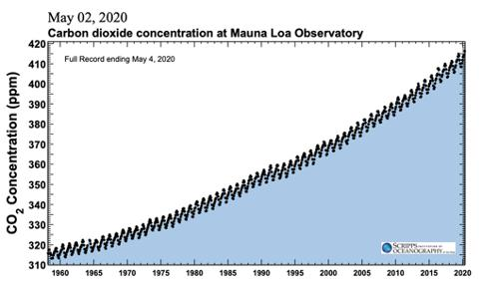

8

This chart shows the increase in carbon in the atmosphere since 1960-a 25% increase.

(If you are wondering about the zigzag on the chart, it is to do with the angular rotation of the planet where the major greener parts of the planet face the sun more on an annual basis thus absorbing more CO2.

Two examples for a green recovery:

Rather than trying to increase GDP year on year New Zealand has an economic plan which hopes to move from Volume to Value Principles:

- Moving the New Zealand economy from volume to value with Kiwi businesses, including SMEs, becoming more productive.
- Ensuring people are skilled, adaptable and have access to lifelong learning.
- Making deeper pools of capital available to invest in infrastructure and grow New Zealand’s productive assets.
- Strengthening and revitalising regional economies.

- Enabling a step-change for the Māori and Pacific New Zealand economies.
- Developing a sustainable and affordable energy system.

- Utilising our land and resources to deliver greater value and improve environmental outcomes.
- Transforming our housing market to improve productivity growth and make houses more affordable.

In Amsterdam the idea is - Out with the global attachment to economic growth and laws of supply and demand, and in with the so-called doughnut model devised by Raworth as a guide to what it means for countries, cities and people to thrive in balance with the planet.

Briefly the doughnut model has been described as “breakthrough alternative to growth economics”.

The inner ring of her donut sets out the minimum we need to lead a good life, derived from the UN’s sustainable development goals and agreed by world leaders of every political stripe. It ranges from food and clean water to a certain level of housing, sanitation, energy, education, healthcare, gender equality, income and political voice. Anyone not attaining such minimum standards is living in the doughnut’s hole.

9

The outer ring of the doughnut, where the sprinkles go, represents the ecological ceiling drawn up by earth-system scientists. It highlights the boundaries across which human kind should not go to avoid damaging the climate, soils, oceans, the ozone layer, freshwater and abundant biodiversity. Between the two rings is the good stuff: the dough, where everyone’s needs and that of the planet are being met.

I will explain more on that in the next issue. But you can look it up on line at https://www.kateraworth.com/doughnut/
Think Green in all you do. Andy

DOING THINGS DIFFERENTLY

How can we move away from being the “Effluent Society”, away from being the Throw Away Society to being a less wasteful, more sustainable and happier society? One part of this transition is the adoption of the circular economy. We need to dismantle the linear economy in which we take or extract raw materials from the Earth, make things we need – or think we need – from them, use these products and then just dispose of them, throw them away and allow our waste to pollute and poison the soil, the water and the atmosphere.

In contrast, in the circular economy, waste is food or a useful resource, in diversity is strength and so we aim to eliminate or minimise waste, pollution and carbon emissions. We continually use and re-use the resources we have, we share, repair, re-make, refurbish, re-manufacture, and recycle. And the price of things we sell and buy should reflect the real costs.

Anyone interested in setting up a Repair Shop for Bentham and district?

Fair Trade people speak of a New Economy …

If you buy Fair Trade goods for example in the Coop or Burton Village Shop, you are part of the “new Economy”.
“Business and trade prioritise human and planetary well-being ….[through] the

circular economy, recycling and upcycling, women in leadership, sustainable agriculture, preserving indigenous skills, traditional carbon-neutral production

10

methods and the use of profit to benefit people and their environment.” [quoted in Green Christian Prayer Guide, May 2020 about Fair Trade Enterprises]

The Renewable Energy Association (REA) reckons “the UK Government can deliver an 85% increase in renewable and clean technology jobs in a decade by implementing better taxation systems and outlining a roadmap for net-zero emissions. Up to 40,000 jobs across solar, wind, storage and electric vehicle charging markets could be added alongside an additional 100,000 bioenergy jobs

– if the UK Government can deliver favourable policy changes. [Green Christian Prayer Guide]
“The economy, COVID19 has made painfully clear, is a wholly owned subsidiary of the environment, dependent on healthy systems. And green investment is increasingly recognised as the best route to prosperity.” This was said by the Daily Mail on 7th April 2020.
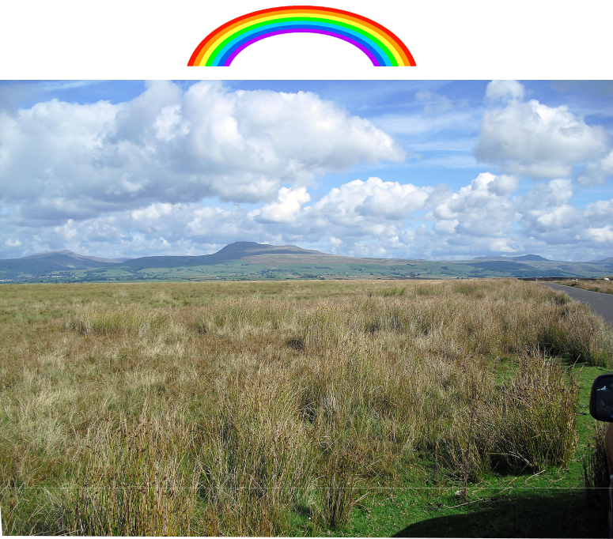

The Three Peaks

11

Long-Eared Owl

Surprised to see this? This was sent to me by someone who wants to remain anonymous to ensure its location is secret. Surprised to see one in this country? That is what Nature does! In the next issue, September, we will be reflecting on our relationship with the natural world. Are we part of Nature or are we set apart from it? Is it our enemy or our friend?
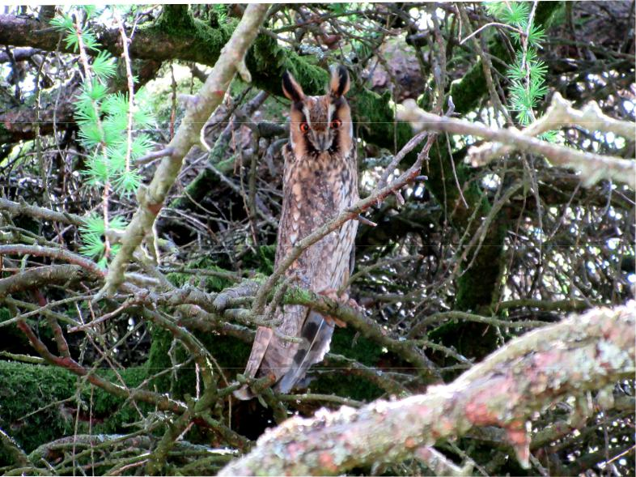

What did you think of this edition? Please contact Timothy Fox, tel 015242 62575 or email wenningfoxes@btinternet.com

